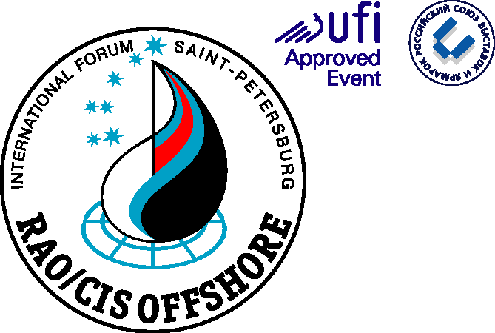

Dear Sirs,

Please be informed that RAO/CIS Offshore International Conference and Exhibition for offshore oil and gas resources development of the Russian Arctic and CIS continental shelf will be held from 12 – 15 September 2017 in St. Petersburg, Russia.
RAO/CIS Offshore has been held since 1993 on the initiative of the Government of the Russian Federation and Gazprom. Today RAO/CIS Offshore is a reputable discussion platform aimed at working out keynote solutions in the framework of international cooperation and recognized by the world business community.
The agenda of the Forum comprises the most important issues for realization of global energy projects in the Arctic and on the shelf: exchange of high technology, reducing environmental risks, development of competence and strengthening of partnership relations.
Over 700 delegates and 200 companies from 20 countries will take part RAO/CIS Offshore 2017 to showcase the current and future projects for offshore oil and gas resources development, advanced technology and engineering solutions. Key Russian oil and gas operators will take part in the event – Gazprom, Rosneft, Lukoil, Gazprom Neft, Novatek and others.
Knowing your company’s unique expertise in offshore oil and gas resources development it is great pleasure to invite you to take part in RAO/CIS Offshore 2017 – to demonstrate your company’s achievements at the Exhibition and to choose a suitable sponsorship program.
We are sure that it is a new step in the development of business interaction in such an important issue as energy resources development. We hope that participation of your company in RAO/CIS Offshore 2017 will be beneficial for your company’s activity in Russia.

RAO/CIS Offshore 2017
Organizing Committee

Phone/ fax: +7 (812) 320 8091
E-mail: oilgas@restec.ru
www.rao-offshore.com

